In-Home Services
Designated Manager
Training Booklet
Missouri Medicaid Audit and Compliance
December 9, 2016

Introduction:

So, You are going to enroll as a Missouri Medicaid Provider for In-Home Services. Or, Maybe you have already enrolled. Either way, you have a big responsibility to care for the Participants of this program.
You are not just a provider, but you are a business! In this business you have to know lots of rules and regulations and follow them in order to be successful. That is what this training is all about.
Don’t just think of it as having to comply with a regulation, think of it as a way you can educate yourself so that you will have a business that prospers and makes an impact on your community.
Don’t just skim through the material. Study it and learn it. Then, when you pass the test, you will be ready to apply what you learned to the business you will be managing.

We wish you the best of success in your In-Home business.

MMAC

General Information

PROGRAM INFORMATION

The Home and Community Based Services (HCBS) Program
- Provides assistance to seniors and adults with disabilities.
- Enables individuals to remain out of nursing facilities.
- Consists of Consumer Directed Services (CDS) and In-Home Services (IHS) programs.
Provider Certification Testing is required by 19 CSR 15-7.021 (14) for the Designated Manager of any contracted IHS agency. Therefore, these training materials, the test review and the test pertain only to the IHS program.

The HCBS Program is operated by three state agencies:
- MO HealthNet Division (MHD): Administers the Missouri Medicaid program. You submit your claims for payment to MHD.
- Missouri Medicaid Audit and Compliance (MMAC): Determines eligibility and compliance of Missouri Medicaid providers. You enroll with MMAC & MMAC performs audits of your billings
- Division of Senior and Disability Services (DSDS): Assesses and authorizes services for Missouri Medicaid participants. DSDS develops and authorizes the care plans
MMAC Provider Enrollment Contracts Unit does the following:
- Reviews the Proposal
- Conducts the Site Visit of your Business
- Executes Your Contract (Participation Agreement)
Information about your contract:
- Contracts include provisions to ensure you are compliant with State and Federal Regulations.
- Contracts expire at least every five (5) years.
- Revalidation of all Medicaid providers is required at least every five (5) years by state and federal regulations. Revalidation means you re-enroll without a break in service or payment.

PROVIDER RESPONSIBILITIES

As stated in the introduction to this booklet, you have a lot of responsibility as a provider and a business owner/manager.

1) Notify MMAC of changes in the business
    - Location, phone, business structure and management
2) Maintain liability insurance and dishonesty bond
3) Providers must hire, screen and monitor employees
    - Contacting credible references
    - Furnish employees with identification
    - Monitor employee files
    - Promote employee safety
    - Screen EDL and FCSR (criminal background)
4) Employee Training:
- Designate trainers
- Code of Ethics, Client Rights, Confidentiality
- Mandated Reporting
    - Abuse, Neglect and Exploitation
    - Suspected fraud related to services
- 5) Monitor services being provided
    - In-home personal care workers cannot be family members of the recipients for whom personal care is provided. A family member is defined as a parent; sibling; child by blood, adoption or marriage; spouse; grandparent or grandchild - 13 CSR 70-91.010(3)(K)(4).
    - Initiate services promptly (within 7 days)
    - Recommend changes to care plans
    - Document undelivered services
    - Address grievances

DESIGNATED MANAGERS
QUALIFICATIONS:
- At least twenty-one (21) years of age
- Meet one of the following requirements:
    - Registered nurse currently licensed in Missouri
    - Possess a Baccalaureate degree
    - Licensed practical nurse currently licensed in Missouri with at least one (1) year of verifiable experience with direct care to the elderly, disabled or infirmed.
    - Three (3) years of experience with direct care to the elderly, disabled or infirm.
- Successfully completed this provider certification course
- Annual attendance at MMAC update meeting
RESPONSIBILITIES
- Day-to-day operation of the agency
- Policy maker
    - Communicable diseases
    - Employee safety
    - Hiring and firing practices
    - Orientation and training of personal care staff
- Record keeping
- Monitor provision of services
    - Service delivery verification monthly
Documentation must be kept on clients
with a delivery rate of less than eighty percent
(80%) of the authorized units of in-home
service.
    - Review care plan change requests

- Annual visit to participant’s residence
    - Evaluate aide’s performance
    - Review the plan of care with participant

REGISTERED NURSE

QUALIFICATIONS
- Registered nurse must be currently licensed in Missouri and
- Have one (1) year of verifiable experience with direct care of the elderly, disabled or infirm.
RESPONSIBILITIES
- Monthly on-site visits (“10% sample”)
- Review of all annual on-site reports completed by supervisor
- Monitor staff to assure services are being delivered in accordance with the authorized care plan and ensure appropriate care plan changes are made.
    - Report any discrepancies or services not provided.
- Direct staff responsible for orientation and training to make sure requirements are met.
- Supervise or direct nurse functions completed by the LPN as set forth in the Personal Care Program Regulation

SCREENING
REQUIREMENTS

As with any business, you begin the employment process with an application.

The Employment Application must contain:
- The employee’s signature
- Documentation sufficient to verify the employee meets age, education, and work experience requirements.
- Documentation of employment and termination dates;
- Consent to pre-employment criminal record check;
- Consent to closed records check;
- Disclosure of all aliases and social security numbers used;
- Disclosure of the applicant's criminal history. This includes any conviction or a plea of guilty to a misdemeanor or felony charge and shall include any suspended imposition of sentence, any suspended execution of sentence or any period of probation or parole;
- Disclosure if the applicant is listed on the employee disqualification list

EMPLOYEE DISQUALIFICAITON LIST (EDL)
- Applicants must be checked prior to hire
- Screen for all aliases and social security numbers used by the applicant
- Current employees must be screened quarterly
- No person on the EDL may be hired for any position
- If current employee is found on EDL screening, they must be terminated immediately
http://health.mo.gov/safety/edl/

FAMILY CARE SAFETY REGISTRY (FCSR)
- The Employee must be: Registered with FCSR prior to client contact
Provider Responsibilities:
- Screening must be completed on the applicant, including all aliases and social security numbers used by the applicant.
- When the provider requests a criminal background check pursuant to section 43.540, RSMo, the requesting entity may require that the applicant reimburse the provider for the cost of such record check. When a provider requests a nationwide criminal background check pursuant to subdivision (1) of subsection 3 of this section, the total cost to the provider of any background check required pursuant to this section shall not exceed five dollars which shall be paid to the state.
http://health.mo.gov/safety/fcsr/

- If an applicant has not resided in this state for five consecutive years prior to the date of his or her application for employment, the provider shall request a nationwide check for the purpose of determining if the applicant has a prior criminal history in other states. The fingerprint cards and any required fees shall be sent to the highway patrol's central repository.

FCSR OUTCOMES

- If a screening results in –
  - No findings:
    - No EDL finding or disclosure of any other crimes
    - Applicant may be hired
  - A finding that is a “disqualifying” crime:
    - Applicant cannot be employed until a Good Cause Waiver has been submitted AND APPROVED.
  - A finding that is NOT a “disqualifying” crime:
    - No EDL finding or disclosure of any “disqualifying” crimes
    - Applicant can be hired conditionally once the Good Cause Waiver has been submitted and the agency verifies submission of the Good Cause Waiver

GOOD CAUSE WAIVER

An individual who has been disqualified from employment with an IHS provider has the right to apply for a Good Cause Waiver (GCW), which, if granted, would not correct or remove the finding, but would remove the hiring restriction and allow the individual to be employed.

Good cause waivers are required for any in-home services employee with a finding on their background screening.
http://health.mo.gov/safety/goodcausewaiver/

An individual who has been placed on the Department of Health and Senior Services EDL is
not eligible to receive a GCW.

DISQUALIFYING CRIMES

- Class A felony violation (of chapter 565, 566, 569)
- Class B felony violation (of chapter 565, 566, 569)
- Any violation of 198.070 RSMo (subsection 3)
- Any violation of 568.020 RSMo

These crimes are known as crimes against persons.

A complete list can be found at: http://health.mo.gov/safety/goodcausewaiver/crimes.php

CONDITIONAL EMPLOYEMENT

- If the finding on the background screening (FCSR) is not a disqualifying crime, the provider can hire the applicant conditionally, pending the results of the Good Cause Waiver (GCW).
- Provider must verify with FCSR that the GCW has been received.
- If the GCW is approved, the applicant can be hired on a permanent basis.
- If the GCW is denied, the applicant must be terminated immediately.
OTHER SCREENINGS

- OIG –LEIE:
  - Office of the Inspector General – List of Excluded Individuals and Entities
    - Guidance recommends monthly screenings of all employees.
    - It is not required for providers at this time.
    - Check the LEIE database at http://exclusions.oig.hhs.gov/
- Licensing and Certification
All documentation regarding screenings should be kept in the personnel file.
Documentation should include:
- Identity of the person who was screened
- Dates the screening was requested and completed
- Outcome of the screening

Documentation must be produced upon request by DSS, MMAC or DHSS.

PERSONNEL
AND
TRAINING
REQUIREMENTS
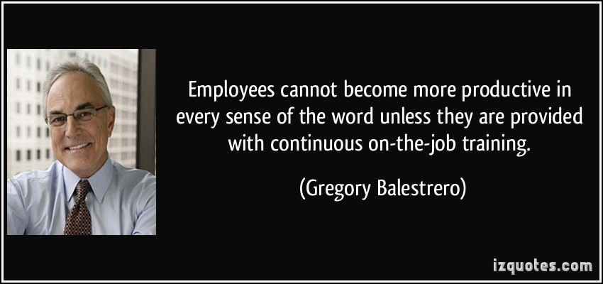
BASIC AIDE QUALIFICATIONS

All in-home service workers shall:
- Be eighteen (18) years of age
- Be able to read, write and follow direction
- Meet one of the following requirements:
    - Six (6) months paid work experience as an agency homemaker, nurse aide, maid or household worker
    - One (1) year experience, paid or unpaid, in caring for children, sick or aged individuals
    - Successful completion of formal training in nurse arts or as a nurse aide or home health aide.

ADVANCED PERSONAL CARE (APC) AIDE QUALIFICATIONS
All advanced personal care and respite aides shall be:
- A licensed practical nurse (LPN); or a certified nurse assistant (CNA)
- Or be documented to have worked at least fifteen (15) hours per week for three (3) consecutive months, successfully, for the provider, as an in-home aide that has received personal care training.

DESIGNATED TRAINER QUALIFICATIONS
The Designated Trainer is responsible for performing basic training sessions
Must be one of the following:
- Registered Nurse
- Licensed Practical Nurse
- Designated Manger or Supervisor
- Experienced Aide Employed by the company at least six (6) months
TRAINING DOCUMENTATION

Written documentation that includes:
  - Employee training record:
    - Dates of all classroom or on-the-job training
    - Trainer’s name
    - Topics, number of hours and location
    - Date of first client contact
    - Aide’s signature
    - Documentation of any waived training
  - Master training record:
    - List of all training sessions held by provider
    - Copy of all agendas showing date, time and duration of sessions
    - Qualifications of trainer (if not agency Registered Nurse)

BASIC TRAINING REQUIREMENTS
- Twenty (20) hours of basic training must be completed within thirty (30) days of employment.
Must include:
  - Eight (8) hours of classroom training prior to client contact
  - Two (2) hours of agency orientation and emergency protocols
  - Four (4) hours of supervised on-the-job training under direction of the designated trainer
  - Alzheimer’s and related dementia training for ALL employees, direct and non-direct care. (DHSS is the Clearinghouse for Alzheimer’s training materials according to 192.2000.1 RSMo)
  - No more than 2 hours of reading material
- Alzheimer’s disease and related dementia (192.2000.1 RSMo)
  - For non-direct care employees:
    - Overview of Alzheimer’s/dementias
    - Communicating with persons with dementia
  - For direct care employees:
    - Overview of Alzheimer’s/dementias
    - Communicating with persons with dementia
    - Behavior management
    - Promoting independence in daily living activities
    - Understanding and dealing with family issues

ADVANCED PERSONAL CARE TRAINING
- Eight (8) hours of advanced personal care classroom training in addition to the required basic training
    - Required training topics can be found in the MO HealthNet Personal Care Manual (Section 13.9.G)
    - Task training of advanced personal care tasks, by the Registered Nurse, prior to participant contact
    - Task training may take place in the classroom or home setting. Requirements are listed in the MO HealthNet Personal Care Manual (Section 13.9.G.2)
    - Task training must be observed and certified by a Registered Nurse

IN-SERVICE TRAINING

- Ten (10) hours of in-serve training annually after the first twelve (12) months of employment
- Six (6) of the required (10) hours must be classroom training.
- Must include updates on Alzheimer’s and dementia diseases
- Training should reinforce and extend the content of basic training

TRAINING WAIVERS
Basic training:
- Two (2) hours of provider agency orientation is never waived
- Waive twelve (12) hours if aide received similar training during the current or preceding year
- Waive twelve (12) hours if the aide was employed as an in-home aide at least halftime for six (6) months or more within the current or preceding state fiscal year
- All but two (2) hours of provider agency orientation waived for a LPN, RN or CNA
    - Must have documentation in the personnel file that includes licensure or certification number that is current and in good standing

Advanced Personal Care (APC) training:
- Waive eight (8) hours of classroom training for currently licensed LPN or CNA, in good standing
- If aide received APC training and was employed at least half-time as an APC aide in the prior 6 months with a DHSS contracted in-home provider
- Task training is only waived for Missouri licensed nurses

TRAINING WAIVER VERIFICATION
It is ultimately the provider’s responsibility to judge whether or not the previous training was sufficient to justify a waiver.
The provider may obtain written or phone verification of the previous training which includes at least the following:
    - The name, address, and phone number of the employer from whom the training was received
    - The date or dates of the training
    - A summary of the content and number of hours of the training
For phone verification, the date of the phone contact, and the name of the person verifying the training information

MISCELLANEOUS TRAINING INFORMATION
In-Service training:
- Only two (2) hours of refresher training annually after being employed for three (3) years and receiving thirty (30) hours of training
- Must have received Alzheimer’s disease and related dementia training

SERVICE STANDARDS

SERVICE AUTHORIZTION
- Referral is received
- Participant is assessed
If participant meets all eligibility and assessment criteria -
- Care plan is developed and services are authorized
    - Completed by Division of Senior and Disability Services
    - Contains a list of tasks to be performed, weekly schedule of service delivery and maximum number of units of service
- Participant is informed of the services available to him or her.

SERVICE INITIATION
- Upon receipt of the personal care plan, the provider of care must initiate care within seven (7) days.
- If services are not initiated within seven (7) days of receipt, detailed written justification must be sent to the division case manager and a copy must be maintained in the client file. (The division case manager is the DSDS employee who approved the client to receive services from you.)

Providers should only bill MHD for services that are on the participant’s authorized care plan.

DISCONTINUING SERVICES
When do you discontinue services?
1) When the client’s case is closed by DHSS.
2) When the provider learns of circumstances that require closure of a case:
  - Death
  - Entry into a Nursing Home
  - Client No longer needs services
ACTION: Notify DHSS in writing and request that the client's services be discontinued.
3) When the client is non-compliant with the plan of care:
ACTION: Notify DHSS in writing of the non-compliant acts and request that services be discontinued.
4) When the client or client’s family abuses the personal care aide or agency staff:
ACTION: Notify DHSS by telephone and submit description Of threats in writing and request that services be discontinued.
5) When the provider cannot meet the maintenance needs of a client:
ACTION:
- Notify DHSS in writing and request that the services be discontinued.
- Provide written notice of discharge to the client or client’s family at least twenty-one (21) days prior to discharge.
- Provide written notice of discharge to DHSS at least twenty-one (21) days prior to discharge.

**Provider must continue to provide care in accordance with the care plan for these twenty-one (21) days or until other arrangements are made by DHSS.**

Basic Personal Care Services:
Basic personal care services are medically oriented, maintenance services provided to a client in the individual’s residence to assist with the activities of daily living, when this assistance does not require devices and procedures related to altered body functions. Each service has certain authorized tasks.
A full list of basic personal care tasks can be found at 13 CSR 70-91.010(2)(B)

Advanced Personal Care Services
Advanced personal care services are maintenance services provided in the client’s home to assist with the activities of daily living when this assistance requires devices and procedures related to altered body functions.
A full list of advanced personal care tasks may be found at 13 CSR 70-91.010(5)(B)

Authorized Nurse Visits
Authorized nurse visits are skilled nursing services of a maintenance or preventative nature provided to clients with stable chronic conditions.
These visits are NOT intended as treatment for an acute health condition.
These visits can be performed by an LPN under RN supervision.
Homemaker Services
Homemaker services are general household activities provided by a trained homemaker.
Services are provided when the client is unable to manage the home him/herself or when the individual responsible for these tasks is temporarily absent.
The full list of tasks can be found at 19 CSR 15-7.021 (7)

Chore Services
Chore services are short term, intermittent tasks necessary to maintain a clean, safe, sanitary and habitable home environment.
They are authorized when the services have been determined by the division as critical in maintaining the client’s health and safety.
They are only provided when no other person is responsible for those services is available.
The full list of chore tasks can be found at 19 CSR 15-7.021(8)

Respite Services
Respite care services are maintenance and supervisory services provided to an individual in his/her residence to provide temporary relief to the normal caregiver.
Services include:
      - Supervision
      - Companionship
      - Direct client assistance

Respite
Types of Respite Care:
- Basic Respite
    - Clients with non-skilled needs
- Advanced Respite
    - Clients with non-skilled needs that require specialized training
- Nurse Respite
    - Clients with special skilled needs
    - Relief for caregivers who live with the client

Service Prohibitions
Only tasks authorized on the care plan may be billed. The provider will not be reimbursed for the following activities:
- Therapeutic or health related activities
- Transportation services
- Administering over-the-counter or prescribed medication
- Performing household services not essential to the client’s needs
- Friendly visiting

Providers should only bill for
Services that have been authorized
On the care plan and have been provided and documented.

Site Visits and Audits
MMAC conducts Site Visits:
Site Visits are done:
  - Pre and post contract/enrollment on all high or moderate risk category providers
  - To verify compliance with Federal and State enrollment requirements
  - Announced or Unannounced, but will be completed during the agency’s normal business hours.
MMAC conducts Provider Audits:
Audits may be conducted:
  - At any time while the provider is enrolled with Medicaid
  - Announced or unannounced
  - By asking for claims, timesheets, employee, consumer/participant files and other forms of documentation.
Sanctions
The following sanctions may be imposed on a provider for program violations or for violations of regulations and laws.
- Education
- Recoupment of overpaid amounts.
- Being placed on a closed end provider agreement.
- Suspension of payments for claims and participation in the MO HealthNet program.
- Termination from participation in the MO HealthNet program.
ELECTRONIC VISIT VERIFICATION

The Electronic Visit Verification requirement went into effect July 1, 2015.
On July 1, 2015, the telephone tracking system became a requirement by law, for IHS and CDS providers. The telephony requirements for IHS providers are found at RSMo 660.023.1. The requirements for CDS providers are found at RSMo 208.909.1.
Electronic Visit Verification (EVV) is defined as: A telephone and computer-based system or other electronic technology used for the purpose of verifying and reporting the delivery of inhome services from the participant’s home and consumer directed services from the participant’s home if the services are being provided there or other location where the service is being provided as authorized by the Department of Health and Senior Services (DHSS),
Division of Senior and Disability Services (DSDS).

The Electronic Visit Verification (EVV) system must utilize one (1) or more of the following:
(A) The participant’s personal landline or personal cellular phone;
(B) Location technologies including Near Field Communication (NFC), Global Position
System (GPS), and Bluetooth Low Energy (BLE);
(C) An affixed electronic device at the participant’s location;
(D) A biometric verification system which utilizes voice pattern identifications; or
(E) Alternative technology which meets the requirements in section (2) of this rule.

At a minimum, the EVV system must meet the following requirements:
(A) Document and verify the participant’s identity, either by the participant’s personal telephone, a unique number assigned to the participant, or through alternative technology;
(B) Document and verify the attendant by the assignment of a personal identification
number unique to the attendant or through alternative technology;
(C) Document the exact date of services delivered;
(D) Document the exact time the services begin;
(E) Document the exact time the services end;
(F) Support changes in the care plan which are approved by the Department of Health and Senior Services;
(G) Allow for the addition of services approved by the Department of Health and
Senior Services;
(H) Be capable of retrieving current and archived data to produce reports of services delivered, tasks performed, participant identity,beginning and ending times of service, and date of services in summary fashion that constitute adequate documentation of services delivered. Any report shall include an explanation of codes utilized by the provider/vendor (e.g., 10 – Personal Care) and include the vendor/provider’s identity by either name of vendor/provider and/or National Provider Identifier (NPI); and Maintain reliable backup and recovery processes that ensure that all data is preserved in the event of a system malfunction or disaster situation.

In instances where a telephone or other electronic verification options, as stated in section (1) of this rule, are not available or accessible in the participant’s home, or the participant refuses to allow the use of EVV, the vendor/provider must have documentation on file explaining the reason the attendant is not using EVV. When not utilizing an EVV system, the vendor/provider shall file a claim for services rendered as specified in 13 CSR 70-3.030.

Documentation

Documentation
“Adequate Documentation” means documentation from which services rendered and the amount of reimbursement received by a provider can be readily discerned and verified with reasonable certainty.”

Required Documentation
The following are required for documentation of services rendered:
- The date of service
- Time spent providing the service (Clock in and out)
- A description of the service (specific tasks)
- Name of the personal care aide providing services
- Participant name and MO HealthNet number (DCN)
- Signature of the participant and the aide for each date of service
- Documents must be readily available for monitoring or inspection.

Accrued Units
- REGULATIONS:
19 CSR 15-7.021 (17)(B)
13 CSR 70-91.010 (4) 3
- Minutes of a particular service may be accumulated to make a unit.
- Partial units cannot be carried over to the next month.
- 15 minutes make 1 unit

Employee/Personnel File Requirements

Personnel files must be kept confidential, protected and include at a minimum:
- Employment application with the personal care aide’s signature showing date of birth, education, work experience, and the date employed and terminated by the service provider;
- Documentation of at least 2 references contacted;
- Documentation of basic and in-service training received;
- Documentation of any waiver or reduction of employment or training requirements;
- Annual performance evaluation which includes observations from at least one on-site visit;
- For supervisory staff, documentation that they have been provided with and have read Section 13.3.A of the MO HealthNet Personal Care provider manual;
- Signed statement(s) verifying that the personal care aide received a copy of the participant’s rights and the code of ethics, and that the provider’s policy regarding confidentiality of participant information was explained prior to service delivery;
- Statement identifying the personal care worker’s position, including whether the employee performs administrative duties for the provider or delivers services to participants; and
- Returned I.D. card for a terminated personal care worker, or documentation of why it is not available.
Participant Files
Participant files must be kept confidential, protected and include at a minimum:
- The Authorization for Services form and the Service Authorization Supplement Form, which documents authorization for all units of service provided;
- Participant time sheets;
- Documentation of undelivered services;
- The RN’s written notes concerning any on-site visits made to the participant;
- Documentation of all correspondence and contacts with the participant’s physician or other care providers;
- Copies of any Provider Feedback Reports transmitted to the state agency case manager; and
- Any other pertinent documentation regarding the participant
Record Retention
- Five (5) years from the date of service (fiscal and medical records for services billed to MO HealthNet)
- Six (6) years for Protected Health Information
- All records must be available for audit or inspection by DHSS, DSS and/or their representative upon request.

HIPPA
The Health Insurance Portability and Accountability Act of 1996 (HIPAA) is a federal law that regulates access to a person’s protected health information.
HIPAA is composed of federal regulations that address:
- Transaction codes
- Security standards
- Privacy standards
HIPAA regulations can be found at 45 CFR, Parts 160, 162 and 164

MANDATED REPORTING
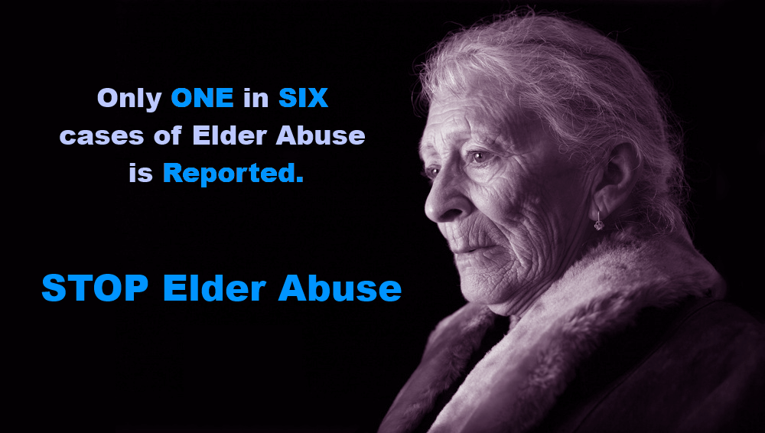
1-800-392-0210
Mandated Reporting

Mandated reporters are people who have regular contact with vulnerable people such as minors, disabled persons between 18 and 59, and senior citizens and are therefore legally required to report (or cause a report to be made) when abuse is observed or suspected.
In-home services owners, providers, operators or employees must report:
- Suspected abuse, neglect or exploitation of disabled persons between 18 and 59 and any person aged 60 or older to 1-800-392-0210
- Suspected abuse, neglect or exploitation of children to 1-800-392-3738
- Suspected abuse, neglect or exploitation of Long Term Care Facility residents to 1-800-392-0210

ELDER ABUSE HOTLINE!
Provider staff and volunteers shall be familiar with and shall be able to recognize situations of possible abuse, neglect, exploitation or likelihood of serious physical harm involving disabled persons and seniors.
Reports shall be made IMMEDIATELY to the
DHSS elder abuse hotline.
1-800-392-0210
**Hotline is open 7am - 12am, 7 days a week**
MISCELLANEOUS INFORMATION

Anti-kickback Laws
(This is not on the test)
- 13 CSR 70-3.030(3)(A) 27
  - “Making any payment to any person in return for referring an individual to the provider for the delivery of any goods or services for which payment may be made in whole or in part under MO HealthNet. Soliciting or receiving any payment from any person in return for referring an individual to another supplier of goods or services regardless of whether the supplier is a MO Health-Net provider for the delivery of any goods or services for which payment may be made in whole or in part under MO HealthNet is also prohibited. Payment includes, without limitation, any kickback, bribe, or rebate made, either directly or indirectly, in cash or inkind;”
- 42 U.S.C. 1320a-7b(b)
  - “Whoever knowingly and willfully solicits or receives any remuneration (including any kickback, bribe, or rebate) directly or indirectly, overtly or covertly, in cash or in kind--
(A) in return for referring an individual to a person for the furnishing or arranging for the furnishing of any item or service for which payment may be made in whole or in part under a Federal health care program, or
(B) in return for purchasing, leasing, ordering, or arranging for or recommending purchasing, leasing, or ordering any good, facility, service, or item for which payment may be made in whole or in part under a Federal health care program, shall be guilty of a felony and upon conviction thereof, shall be fined not more than $25,000 or imprisoned for not more than five years, or both.

IN-HOME REGULATIONS/STATUTES

- Service Standards – 19 CSR 15-70.021
- Personal Care Program – 13 CSR 70-91.010
- Sanctions for false or fraudulent claims- 13 CSR 70-3.030
- Good Cause Waiver – 19 CSR 30.82.060
- FCSR – RSMO 192.2495.2 (formerly 660.317)
- EDL – RSMO 192.2495.2 (formerly 660.315)
- Mandated Reporters – RSMO 192.2400 (formerly 660.300)
- Alzheimers – RSMO 192.2000 1 (8) (1) (formerly 660.050)

Disqualifying Crimes

- Class A felony violation (of chapter 565, 566, 569)
- Class B felony violation (of chapter 565, 566, 569)
- Any violation of 198.070 RSMo (subsection 3)
- Any violation of 568.020 RSMo
These crimes are known as crimes against persons.
A complete list can be found at: http://health.mo.gov/safety/goodcausewaiver/crimes.php

