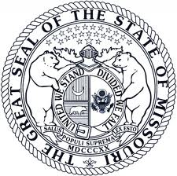 | MISSOURI DEPARTMENT OF SOCIAL SERVICES  MISSOURI MEDICAID AUDIT & COMPLIANCE  ANNUAL SERVICE REPORT FOR CONSUMER DIRECTED SERVICES (CDS) VENDOR

Provide three examples of positive impacts on Medicaid consumers’ outcomes through the CDS services provided by your agency during the past calendar year (Three for your agency – not three for each consumer). Continue on additional sheets if needed. Do not include any name or DCN numbers.
1.

2.

3.

ANNUAL CERTIFICATION
I certify, to the best of my knowledge and belief, that all quarterly CDS service and financial reports required by 19 CSR 15-8.400 were submitted to Missouri Medicaid Audit & Compliance during the past calendar year.
☐ Check this box if you did not have any authorized CDS clients during the past calendar year.
Reports that are not complete, signed, and/or include the printed name and title of the submitter will be rejected.
SIGNATURE OF AUTHORIZING CERTIFYING OFFICIAL | DATE THIS REPORT WAS SUBMITTED
TYPED OR PRINTED NAME AND TITLE OF PERSON SIGNING | BUSINESS TELEPHONE NUMBER
FULL LEGAL NAME OF CDS VENDOR

NPI
PROVIDER EMAIL

Please submit this report with your 4th quarter CDS service and financial reports to:

Email: MMAC.CDS@DSS.MO.GOV Fax: 573-526-4375

Missouri Medicaid Audit & Compliance, P.O. Box 6500, Jefferson City, MO 65102

